**PROJECT REPORT**

1. **An introduction to the project and objectives:**

SunPower Solutions specializes in installing solar panels for residential and commercial properties. They operate in a market influenced by factors such as regional solar subsidies, environmental awareness, and the decreasing cost of solar technology. The company is considering expanding into new regions and needs to optimize its pricing and operational strategies.

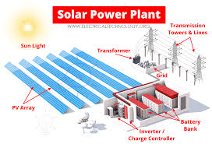  
**Solar Power System Diagram**

The image above depicts the standard configuration of a solar power plant. Photovoltaic (PV) modules receive sunlight, producing DC power transmitted to inverters via a Junction Box and String Monitoring Box. Inverters then convert DC power into AC power, which is elevated through transformers to align with the grid voltage. The final step involves supplying the power to the grid through designated switchgear.

This group work embarks on an exploration into the world of solar power generation, underpinned by extensive [datasets](https://drive.google.com/drive/folders/1UU5NZuUUiq5d1TKU57waBX6tkpX_ORYi?usp=sharing) collected from two solar power plants. Spanning a comprehensive 34-day period, this dataset unveils the intricate dynamics of solar power through a distinct lens, offering invaluable power generation and sensor readings data.

1. **Dataset Overview:**

At the heart of this dataset lies a pair of intertwined files for each plant. These pairs encapsulate the essence of solar power generation, comprising power generation datasets and sensor readings datasets. The former focuses on the inverter level, the nexus of energy conversion, while the latter delves into the plant level, capturing the broader environmental context that influences solar energy output.

1. **Dataset Parameter:**

Delve into the wealth of information provided by this dataset, which encapsulates vital parameters essential for understanding solar power generation and plant health. These parameters include:

**Date and Time (DATE_TIME):**

The timestamp of each observation, captured at 15-minute intervals, offering temporal context to the dataset.

**Plant ID (PLANT_ID)**:

This unchanging identifier signifies the specific solar power plant from which the data originates.

**Inverter ID (SOURCE_KEY - Power Generation Data)**:

The unique key corresponding to individual inverters, enabling analysis of power generation metrics.

**DC and AC Power (DC_POWER and AC_POWER - Power Generation Data)**:

Metrics quantifying power generated by each inverter within 15-minute intervals, measured in kilowatts (kW).

**Daily Yield (DAILY_YIELD - Power Generation Data)**:

The cumulative sum of power generated up to a specific point within the day.

**Total Yield (TOTAL_YIELD - Power Generation Data)**:

Cumulative power generated by each inverter up to a specific point in time.

**Sensor Panel ID (SOURCE_KEY - Sensor Readings Data)**:

A unique identifier for the sensor panel, facilitating observations related to ambient and module temperatures, as well as irradiation.

**Ambient Temperature, Module Temperature,** and **Irradiation (AMBIENT_TEMPERATURE, MODULE_TEMPERATURE, and IRRADIATION - Sensor Readings Data)**:

Parameters observed at 15-minute intervals, providing insight into environmental conditions that influence solar energy conversion efficiency.

1. **Data Exploration and Insights:**

The power generation datasets encapsulate a wealth of information, chronicling the power generated by individual inverters at 15-minute intervals. Through metrics like DC_POWER and AC_POWER, we gain insight into the energy conversion process, understanding the transformation from direct current to alternating current. The journey is further enriched by cumulative metrics such as DAILY_YIELD and TOTAL_YIELD, painting a picture of sustained energy production over time.

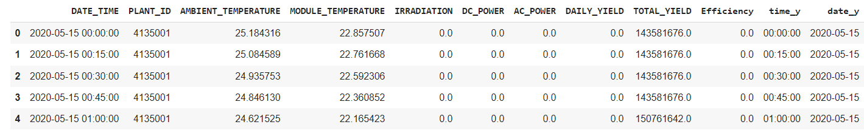

1. **Detailed methodology describing how the data was used and analyzed with calculus concepts:**
2. Use the data to analyze how solar panel efficiency behaves as environmental conditions (like sunlight intensity) approach certain operational limits. Examine if there are points of discontinuity or leveling off in efficiency.

Power output is generated with the presence of sunlight, which starts at around 05:33 hrs and ends at around 18:00 hrs. We can confirm the correlation between power generation and the sunlight of the solar panel efficiency, we see on the above graphs either DC_Power and Irradiation start rising after 5:33 when the Sun Set On at the beginning of the day and it starts fall after 16:40 as the Sun Set Off at the end of the day(see below graph)

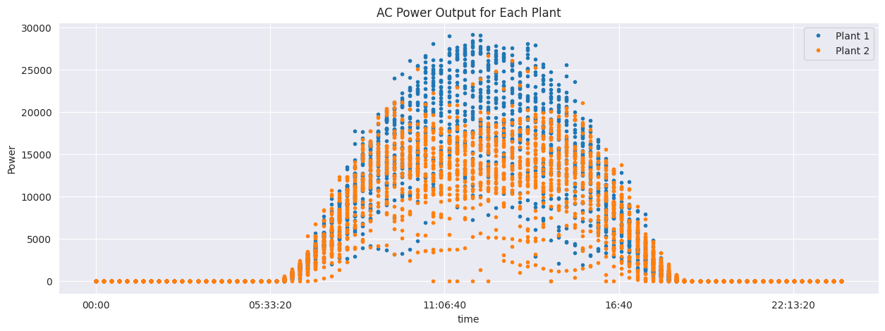

We observe that the efficiency of Plant 1 rose to the highest when the Sun set On at the beginning of the day(05:33) and it stays high until the Sun sets Off after 16:40, where we observe the drop of efficiency at around 18:00. While for Plant 2 during the day they were a drop of efficiency at 11:06 which might be due to the rain that causes less irradiation(Sunlight intensity)(See below two graph)

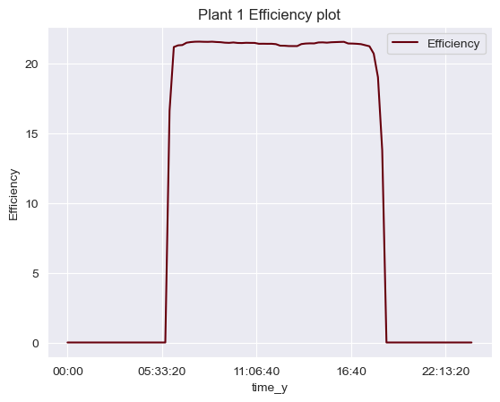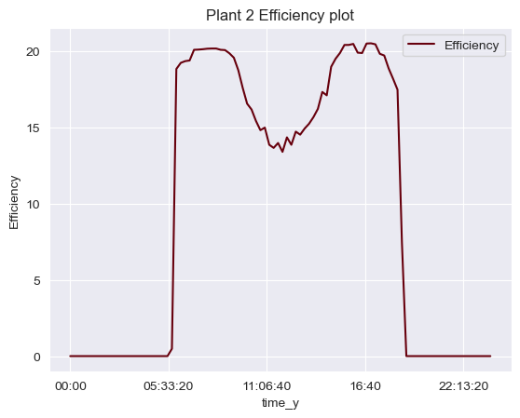

Plant 1 has higher correlation between DC_power and AC_Power, which means that Plant 1 has a higher overall system efficiency than Plant 2, despite having similar inverter efficiency.

1. Utilize the dataset to model how changes in factors like sunlight intensity or panel orientation impact the rate of energy production. This involves calculating the derivative of the energy output with respect to these variables.

We can see Energy output points are distributed in linearity model as the Sunlight Intensity increases, which means if the solar panel is positioned to maximize the sunlight intensity it will result in consistent rate of energy production(see below graph)

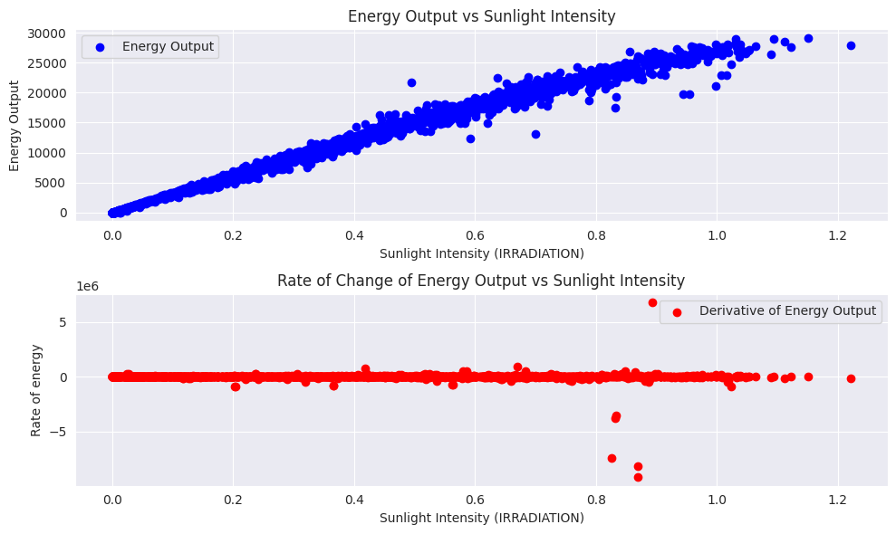

1. Analyze cumulative solar energy production over time by integrating the power output data. This can help in understanding total energy yield under different conditions over a specific period.

We can observe the graph of cumulative energy production as in the morning it is below of 25000 and it goes on increasing all along the daily hours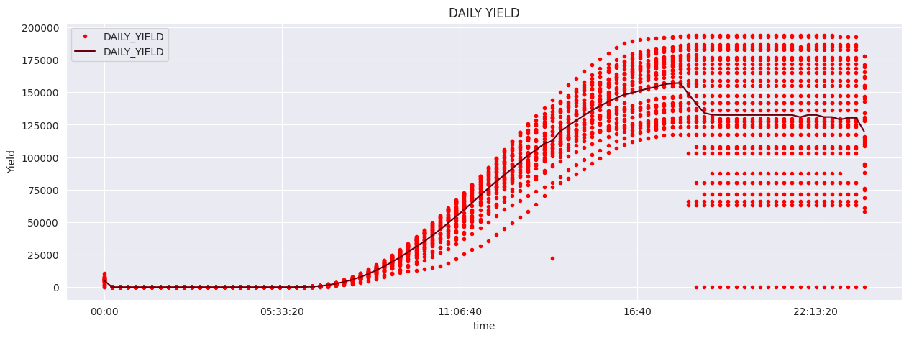

1. Create models using differential equations to predict future trends in energy production based on current and past data trends. This can involve formulating equations that describe the rate of change in energy output.

After performing the prediction with linear model

**The linear equation can be written as:**

**y** = -393.18 - 21.13 * **A** + 48.07 * **M** + 26684.08 * **I**

**AC_POWER** = -393.18 - 21.13 * **AMBIENT_TEMPERATURE** + 48.07 * **MODULE_TEMPERATURE** + 26684.08 * **IRRADIATION**

Where: the predicted output are y(AC_POWER), then (AMBIENT_TEMPERATURE), M(MODULE_TEMPERATURE), and I(IRRADIATION) are the input variables.

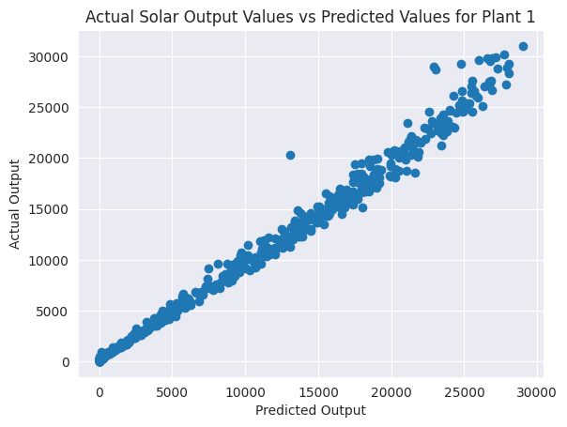

We can see our data are linear distributed, which means the model prediction performance is good.

**VI. Insights and conclusions derived from the analysis**.

Regression models were developed to forecast AC Power based on ambient temperature, module temperature, and ground irradiation, utilizing previously collected hypothesized weather data related to power production. Despite experiencing different temperature variations, both plants appear to receive a comparable daily sunlight exposure. However, Plant 2 displays a slightly more erratic pattern with extreme irradiation values. This discrepancy might suggest that Plant 2 is situated in a region characterized by more rainfall or cloud cover compared to Plant 1. Alternatively, it could indicate that Plant 2 is located at a higher elevation, where there is less precipitation or cloud cover and lower temperatures. Another possibility is that the modules in Plant 2 may require maintenance.